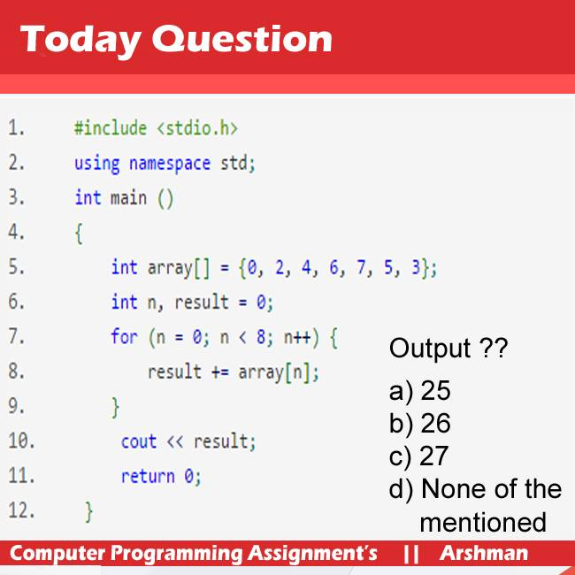

//#include<iostream>

//using namespace std;

//int main()

//{

// int ary[]={0,2,4,6,7,5,3};

//

// int result=0;

// for(int n=0;n<8;n++)

// {

// result+=ary[n];

//

// cout<<result<<endl;

// }

// getchar();

// getchar();

// return 0;

//

//}

////////////////////////2nd picture

#include<iostream>

using namespace std;

int main()

{

int ary[]={0,2,4,6,7,5,3};

int result=0;

for(int n=0;n<8;n++)

{

result+=ary[n];

}

cout<<result<<endl; // in this method it show the address because index is 8 and show that index address

getchar();

getchar();

return 0;

}